1. Load the data and check the summary

train_data = read.csv("train.csv", header=TRUE, sep=",")

summary(train_data)

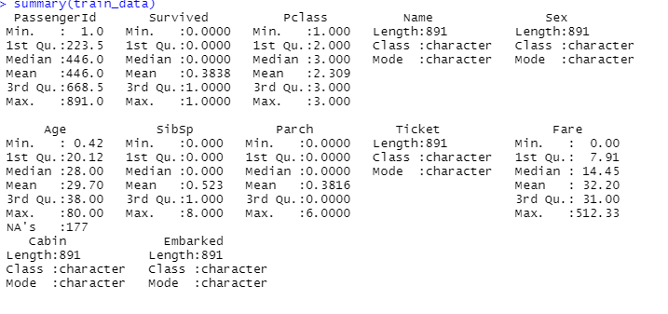

The train dataset contains above variables with respective lengths.

1. Data preparation: check for null values and remove them.

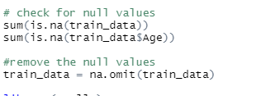

1. Plot the correlation matrix with all numerical variables to find the relation between the variables

1. Creating plots to interpret the results

The above plot describes the survival of passengers by gender. We can observe that in total female passengers has survived more than female passengers. And a smaller number of people survived in general.

The above graph is describing the Class of the passengers and their survival status. We can observe that first class passengers relatively survived than others.

The above graph tells the survival rate of passengers by Embarked. The S embarked seems to be survived more than others.

The above graph tells the survival of passengers by boarding and class. The S boarding of 3rd class has high survival rate.

The above graph describes the surval rate by Age. The people in 20 to 40 age has survived most than the others.

From the above graph, the passengers having no, or one member of the family survived more than others.